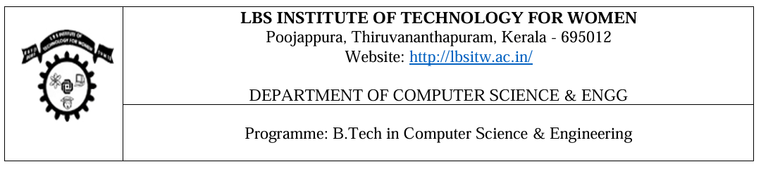

PROJECT

PO–PSO–SDG MAPPING

Project Title | NAS Medical Model Generator
Project Type | Application
Project Category | Healthcare / AI / Data Analytics
Guide Name | Project Guide
Semester and Class | Semester VIII - CSE

PARTICIPANTS DETAILS

Group ID | Roll No | Register Number | Name of Student

PROJECT DESCRIPTION

PROJECT TYPE AND CATEGORY

PSO No. | Program Specific Outcomes (PSO)
PSO1 | Apply mathematical models, software engineering principles and programming paradigms to solve real world problems.
PSO2 | Comprehend various aspects of computer hardware, communication models and security principles for developing computing solutions

PO No. | Program Outcomes (PO) | PO No. | Program Outcomes (PO)
PO 1 | Engineering knowledge | PO7 | Environment and sustainability
PO 2 | Problem analysis | PO8 | Ethics
PO 3 | Design/development of solutions | PO9 | Individual and teamwork
PO 4 | Conduct investigations of complex problems | PO10 | Communication
PO 5 | Modern Tool usage | PO 11 | Project management and finance
PO 6 | The engineer and society | PO12 | Life-long learning

MAPPING WITH PO, PSO AND SDG (3/2/1: High/Medium/Low)

Project Title | ProjCategory | ProjType | Program Outcomes (PO) |  |  |  |  |  |  |  |  |  |  |  |  | PSO |  |  | SDG
 |  |  | PO 1 | PO 2 | PO 3 | PO 4 | PO 5 | PO 6 | PO 7 | PO 8 | PO 9 | PO 10 | PO 11 | PO 12 | PSO 1 |  | PSO 2

PROGRAM OUTCOME (PO) MAPPING WITH JUSTIFICATION

PO | Mapping Level | Justification
PO1 – Engineering Knowledge | 3 | Implements ML fundamentals, preprocessing, backend APIs, and model training workflows.
PO2 – Problem Analysis | 3 | Analyzes mixed-type medical data, task detection logic, and model selection criteria.
PO3 – Design & Development of Solutions | 3 | Designs a complete upload-to-inference pipeline with modular components.
PO4 – Investigation of Complex Problems | 3 | Evaluates multiple candidate architectures and ranks them by validation performance.
PO5 – Modern Tool Usage | 3 | Uses modern tools: Flask, TensorFlow, scikit-learn, Pandas, NumPy, joblib, Chart.js.
PO6 – Engineer and Society | 2 | Targets healthcare prediction use-cases with clearly stated prototype limitations.
PO7 – Environment & Sustainability | 2 | Uses bounded search space and CPU-oriented execution for resource-aware operation.
PO8 – Ethics | 2 | Maintains evidence-based reporting and avoids unsupported model-performance claims.
PO9 – Individual & Team Work | 2 | Integrates frontend, backend, and ML modules in a coordinated project workflow.
PO10 – Communication | 3 | Provides structured documentation and report artifacts for technical communication.
PO11 – Project Management | 2 | Applies constrained run settings and artifact lifecycle management per training run.
PO12 – Life-long Learning | 3 | Demonstrates continuous learning through NAS concepts and practical implementation.

PROGRAM SPECIFIC OUTCOMES (PSO) MAPPING

PSO | Mapping Level | Justification
PSO1 –Software Development Skills | 3 | Built an end-to-end AI application including preprocessing, NAS search, model training, and prediction.
PSO2 – Hardware, Security, Intelligent Systems & Data Analytics | 3 | Integrated backend routes, streaming updates, persistence, and schema-driven prediction interface.

SUSTAINABLE DEVELOPMENT GOALS (SDG) MAPPING

SDG | Goal | Justification
SDG 3 | Good Health and Well-Being | Supports health-risk prediction experimentation through reproducible ML workflows.
SDG 4, SDG 9 | Quality Education; Industry, Innovation and Infrastructure | Serves as an educational AI system and demonstrates modern digital innovation practices.

